**Riders, Times off and Clubs represented**

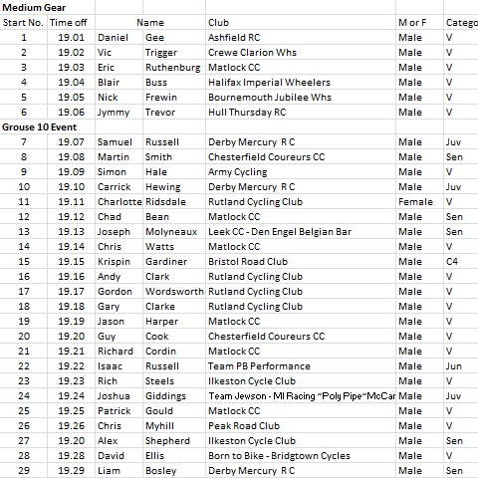

**Officials**

Timekeepers: Members and friends of Matlock CC

Marshals: Members and friends of Matlock CC

Event Secretary: Mr. A. Spriggs, 59 Jubilee Court, Belper, Derbyshire DE56 1NN (07815) 543793 OR (07964) 549788

**Event HQ**

Rowsley Village Hall, School Lane/Woodhouse Road, Rowsley, Derbyshire. Open at about 6pm. There is car park on station road opposite the Grouse and Claret. The result board will be in the hall. The signing on sheet and the numbers will be in the hall. Numbers can be exchanged for a drink in the hall after your ride. The hall is on School Lane/Woodhouse Road which is opposite the Peacock on the A6 in Rowsley. Post code for the hall is DE4 2ED.

Note: The numbers will be in the event HQ, not at the start

**Prizes 1st £20, 2nd £10**

**Team: 3 at £3**

**Medium Gear 1st £10, 2nd £5**

**1st Vet £10, 2nd Vet £5**

**1st Lady £10, 1st Juvenile £5**

**One prize per rider except for team**

**Course Record (20:05) - £30 if you can beat it!**

**These prizes will** not **be presented at the event**

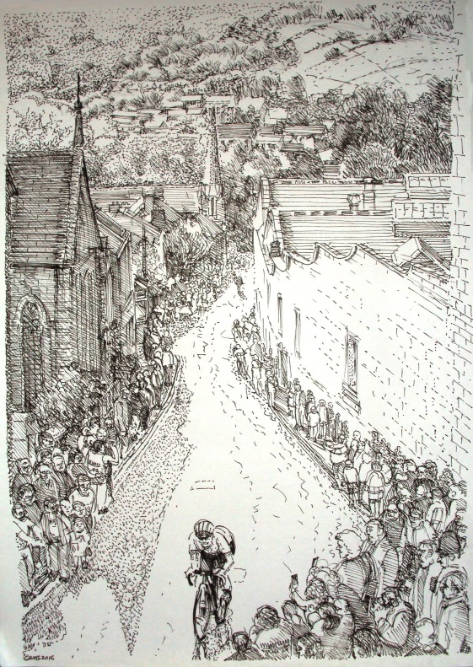

**Promoted for and on behalf of Cycling Time Trials under their Rules and Regulations**

**Tuesday, June 4TH 2019, 19:00** (first rider of 19:01)

**10 mile GROUSE Open Time Trial and**

**Medium Gear Event**

***Promoted by Matlock CC***

Event Secretary: Mr. A. Spriggs, 59 Jubilee Court, Belper, Derbyshire DE56 1NN

Sponsors: Stanley Fearn Cycles/Chubb & Co/First Ascent

**Course**

10 miles, A10/16. Start: On A6 by lamp post no. T55798, north of Church Lane, Darley Dale. No cars are to be parked in this lay-by. Riders must stay within the confines of the lay-by and not spill out onto the road. A maximum of 8 riders can be accommodated in this lay-by. (This is also the start of the A25/12)

Go north along the A6, pass through Rowsley (beware of the pelican crossing to the north of the bridge) and continue to Bakewell. Carefully encircle the island – it is much smaller than you think! Return along the A6 through Rowsley, past the start to finish by a white marker, just to the north of Whitworth Road, Darley Dale and about 200m before the Grouse. Please pay special heed to other road users at all times and at junctions with other roads. Keep your heads up! Have a safe and successful ride!

In the interest of your own safety, Cycling Time Trials and the Event Secretary strongly advise you to wear a hard shell helmet that meets an internationally accepted safety standard and to use a rear light

In the interest of your own safety, Cycling Time Trials and the Event Secretary strongly advise you to wear a hard shell helmet that meets an internationally accepted safety standard and to use a rear light